**ECE 412 Product Design Specification**

Due on Friday, February 7, 2020

Team: 11

ODIN II

### (Product Design Specification)

**Abram Fouts**

**Karla Barraza**

**Todd Townsend**

**Xuening Jia**

**Wenhao Cheng**

**Team 11**

**ECE 412**

**Winter 2020**

Table of Contents

(Product Design Specification) 2

**Introduction:** **4**

**Purpose of the Product Design Specification Document:** **4**

**Project Overview:** **4**

**Market Analysis:** **5**

**Requirements:** **5**

**System Architecture:** **7**

Block Diagram 7

**Design Specification:** **7**

**Documentation:** **8**

# Introduction:

Recently, about 4% of Americans suffer from Eye divergence issues. Medical terminology is called strabismus, which means abnormal alignment of the eyes. There are many forms, like Amblyopia (Lazy Eye), Diplopia (Double Vision), Oculomotor Palsy (Unsteady Gaze), Oculomotor Paralysis (Fixed Gaze) and other conditions (physical abnormalities, nerve damage, muscle damage). Here are some current solutions: like Prism Glasses, Physical Therapy, and Surgery. However, users might face problems like hard to calibrate, less effective after age 7, and high risk. Therefore, The purpose of this project is to use a VR device to track the gaze vectors and let each eye be presented with the corrected Field Of View.

# Purpose of the Product Design Specification Document:

The purpose of the product design specification is to confirm that the subsequent design and development of the product can meet the needs of the users. The project must meet all the requirements that “Must” be completed in the specification document. “Should” and “May” are additional but not necessary.

# Project Overview:

This project is to solve this situation by capturing the gaze vectors of both eyes. Then set the correction vector which can be obtained by calculating. Therefore, each eye will be presented with the correction FOV. In this project, we are going to convert the existing code for the FOV VR headset to work with the new HTC Vive Pro Eye headset. Read in gaze vectors from the user and manipulate the environment in the affected eye through the use of the touch controllers until the user can see the images normally.

# Market Analysis:

People who suffer from any misalignment of the eyes. The main focus for us is strabismus. This is an alternative to people having to patch their strong eye and use their weak eye. This is also a substitute for surgical options.

# Requirements:

**1. Functional Requirements:**

|  |  |  |  |
| --- | --- | --- | --- |
| Requirement # | Requirement | Priority | Station Location |
| 1.1 | Establish Host Environment | Must | Host |
| 1.2 | Build Host Environment | Must | Host |
| 1.3 | Software Migration FOV to HTC Vive Pro Eye | Must | Peripheral Component |
| 1.4 | Integrate Gaze Vectors into Correction Vectors | Must | Software |
| 1.5 | Integrate touch controller | Must | Peripheral Component |
| 1.6 | Host the program within SteamVR | Must | Software |
| 1.7 | Adjust the view plane per individual eye to match the current gaze vector | Should | Software |

**2. Performance Requirements:**

|  |  |  |  |
| --- | --- | --- | --- |
| Requirement # | Requirement | Priority | Station Location |
| 2.1 | Integrate High Speed VR Platform | Must | Peripheral Component |
| 2.2 | Integrate High Performance Host CPU with VR Headset | Must | Host |
| 2.3 | Establish vectors to Host at High Rate of Inference | Must | Host |
| 2.4 | High Speed Correction Vector data | Should | Host |
| 2.5 | Correction/Cure of strabismus through the use of VR | Should | Host/Peripheral |

**3. Economic and Marketing Requirements:**

|  |  |  |  |
| --- | --- | --- | --- |
| Requirement # | Requirement | Priority | Station Location |
| 3.1 | Affordable Host Platform | Must | Host |
| 3.2 | Affordable VR Headset | Must | Peripheral Component |
| 3.3 | Available to all demographics | Must | All components |

**4. Power Requirements:**

|  |  |  |  |
| --- | --- | --- | --- |
| Requirement # | Requirement | Priority | Station Location |
| 4.1 | 12 Volt Power Supply | Must | Host |
| 4.2 | USB Power Supply | Must | Peripheral Components |

# System Architecture:

## Block Diagram

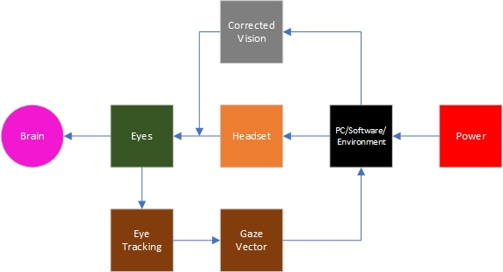

# Design Specification:

* **Host Platform**
  + Processor: Intel SKL-S Xeon CPU E3-1275 v5 @ 3.60 GHz
  + Architecture: x86_64
  + Graphics: NVIDIA® GeForce® GTX 970 or AMD Radeon ™ R9 290
  + Memory: =>4 GB RAM
  + Video out: =>DisplayPort 1.2
  + USB ports: =>1x USB 3.0
* **HTC Vive Pro I**
  + Display: OLED
  + Resolution: 1440 x 1600 pixels per eye
  + Refresh Rate: 90 hz
  + Platform. SteamVR
  + Field of View: 110 °
  + Lens Type: Fresnel
  + Focal Length: 60.8-74.6mm
* **Software**
  + High Level
    - Unity Software
  + Low Level
    - Steam VR Software

# Documentation:

Harper, H. (2020). *Project ODIN.* Intel. <https://drive.google.com/file/d/1JxkFA4xFMCXqU99b7ZcfS6Ko29alLxxa/view?usp=sharing>

(2020). *Intel Xeon Processor E3-1275 v5.* Intel. <https://ark.intel.com/content/www/us/en/ark/products/88177/intel-xeon-processor-e3-1275-v5-8m-cache-3-60-ghz.html>

(2020). *Vive Pro.* Vive. <https://www.vive.com/us/product/vive-pro/>